Lab 2: Basic Linux Commands

1. lscpu

Interpretation:

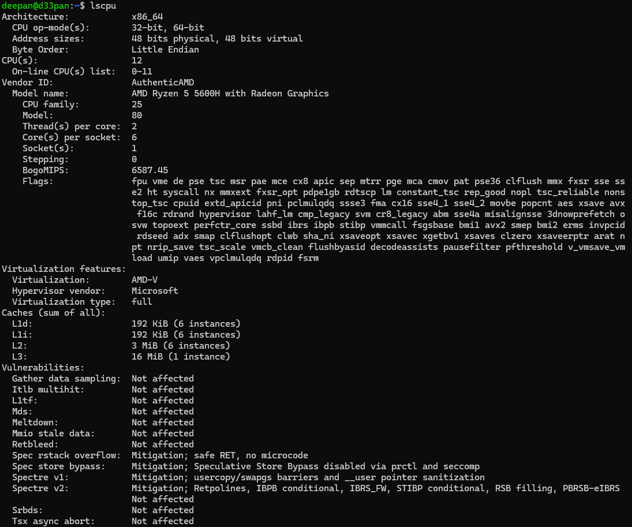display information about the CPU architecture Output:

1. lshw

Interpretation:

extract detailed information on the hardware configuration of the machine.

Output:

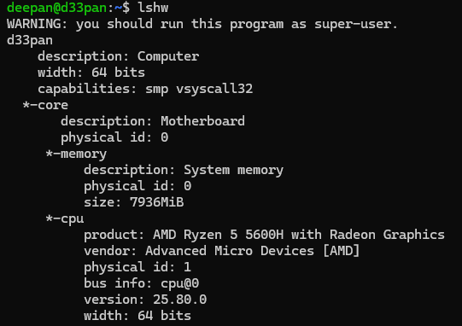

1. sudo lshw Interpretation:

extract detailed information on the hardware configuration of the machine.

Output:

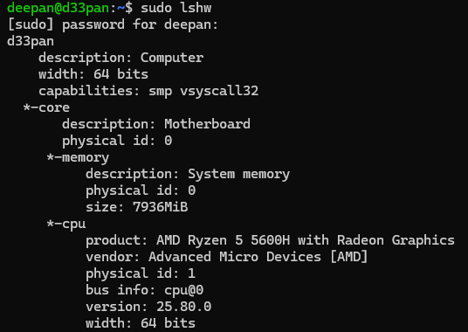

1. hwinfo

Interpretation:

hwinfo is used to probe for the hardware present in the system. It can be used to generate a system overview log which can be later used for support.

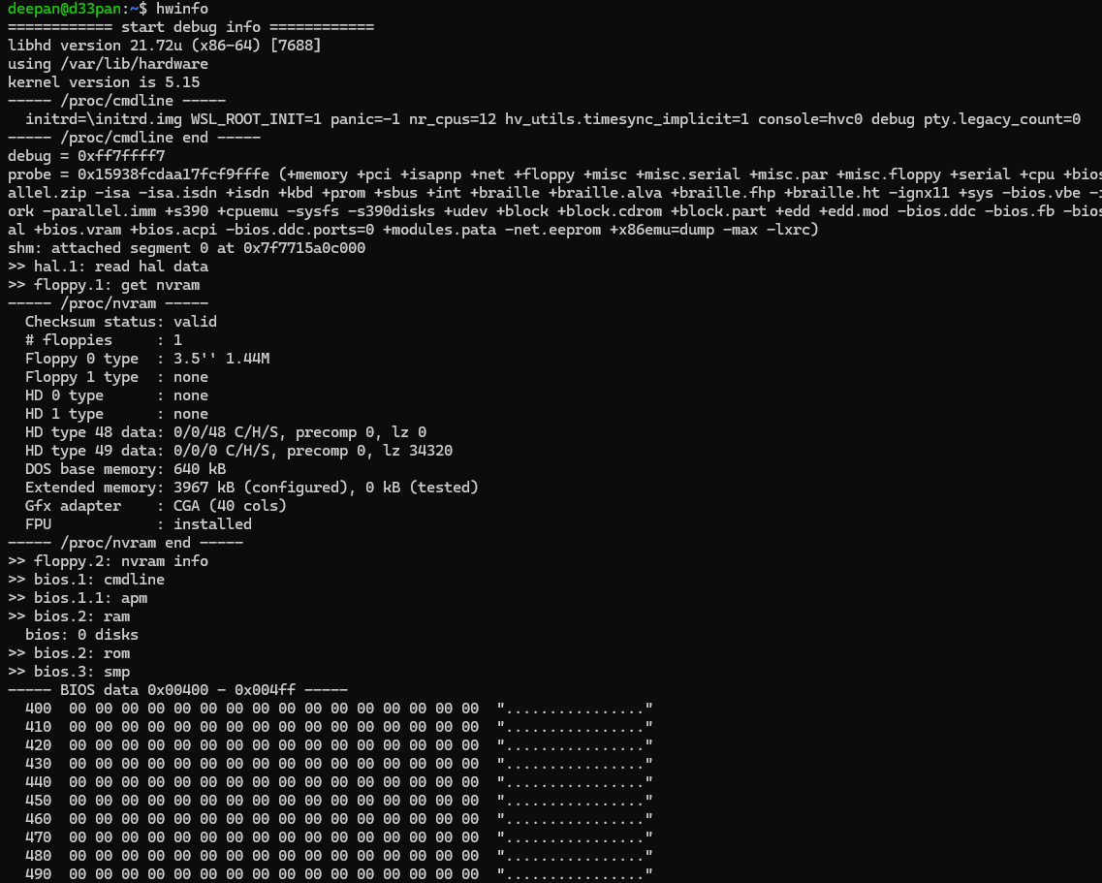

Output:

1. hwinfo **–-**short Interpretation:

shows only a quick summary of hardware present in the system.

Output:

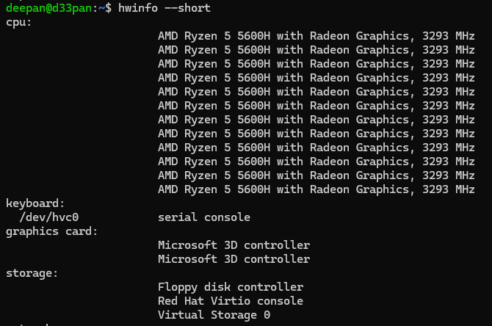

1. lspci

Interpretation:

displays information about PCI buses in the system and devices connected to them

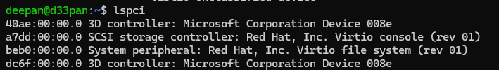Output:

1. lsscsi

Interpretation: list SCSI devices (or hosts) currently attached to the system.

Output:

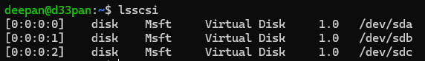

1. lsusb

Interpretation:

displays information about USB buses in the system and the devices connected to them. It uses udev's hardware database to associate a full human-readable name to the vendor ID and the product ID.

Output:



1. inxi

Interpretation:

Command line system information script for console and IRC Output:

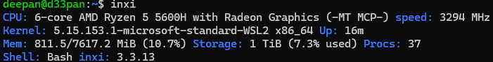

1. inxi -fx Interpretation:

Show all CPU flags used, not just the short list Output:

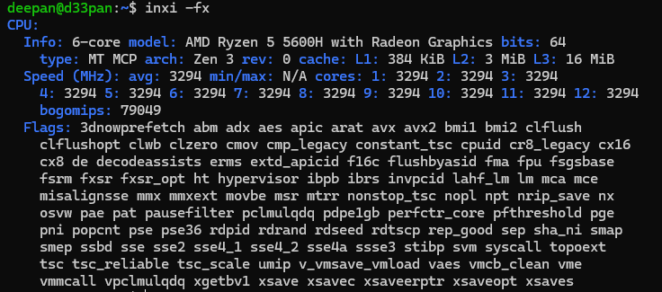

1. 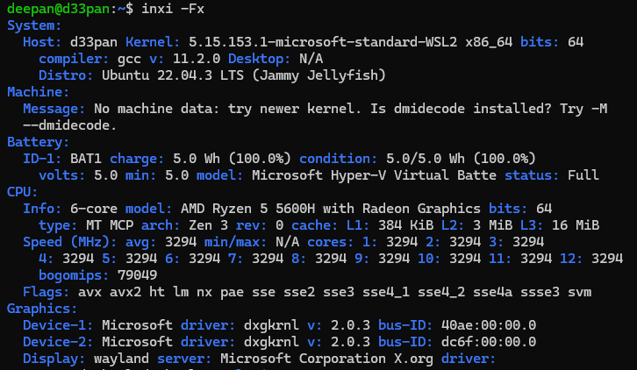 inxi -Fx
2. lsblk

Interpretation:

lists information about all available or the specified block devices.

Output:

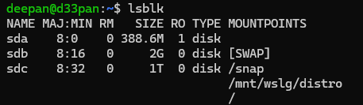

1. df

Interpretation:

displays the amount of space available on the file system containing each file name argument. If no file name is given, the space available on all currently mounted file systems is shown.

Output:

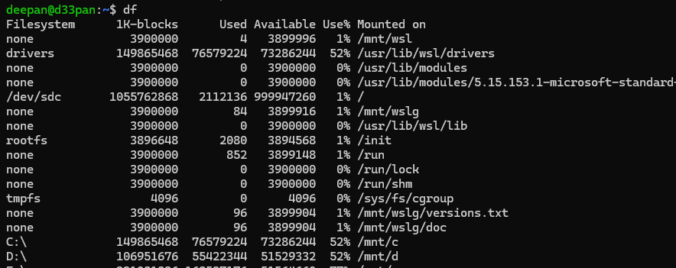

1. pydf

Interpretation:

python script that displays the amount of disk space available on the mounted filesystems, using different colours for different types of filesystems.

Output: 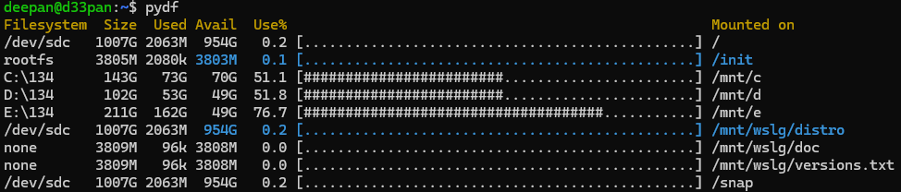

1. fdisk

Interpretation:

dialog-driven program for creation and manipulation of partition tables. It understands GPT, MBR, Sun, SGI and BSD partition tables.

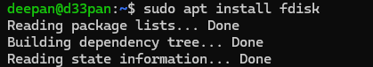

1. fdisk -l Interpretation:

List the partition tables for the specified devices Output: 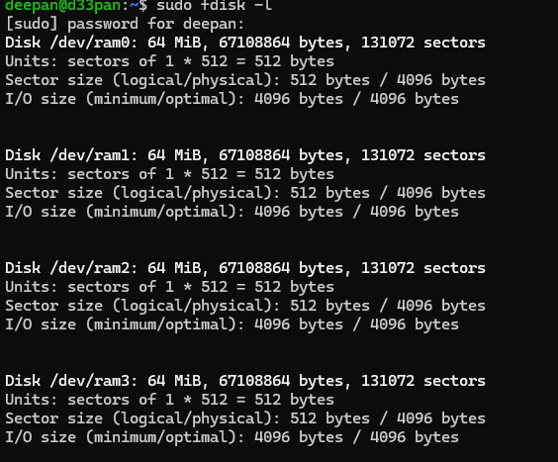

1. free

Interpretation:

Display amount of free and used memory in the system Outpu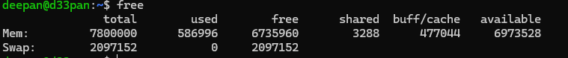t:

1. dmidecode -t processor

Interpretation:

dumps the computer's DMI (some say SMBIOS) table contents in a human-readable format and -r processor allows to dump the processor’s information

Output: 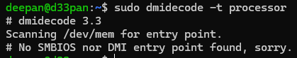

1. dmidecode -t memory Interpretation:

-t memory allows to dump the memory devies’ informations Output: 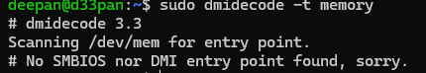

1. dmidecode -t bios Interpretation:

-t bios allows to dump the BIOS Information Output: 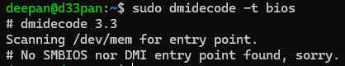

1. cat /proc/cpuinfo Interpretation:

read the file /proc/cpuinfo to output the processor’s information like cpufamily, model, microcode, flags, address sizes, cache_allignments,etc.

Output: 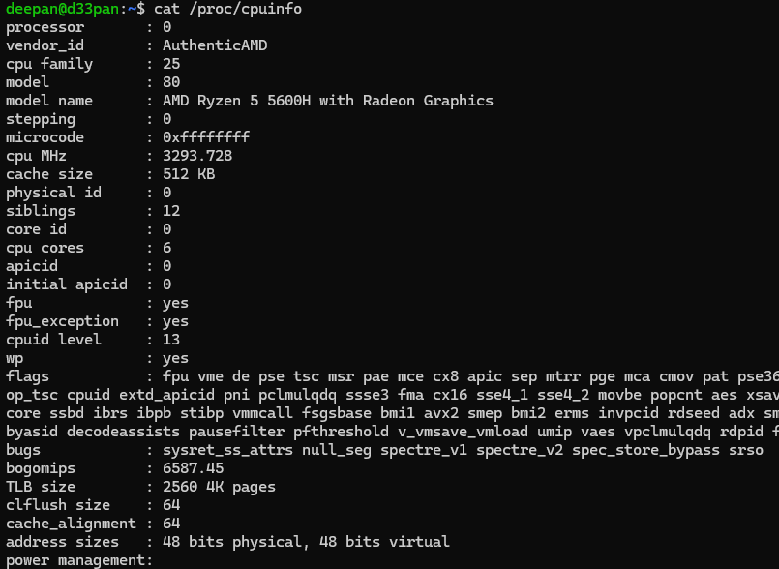

1. cat /proc/meminfo Interpretation:

reads file /proc/meminfo and output the various information of memory segments of the computer system

Output:

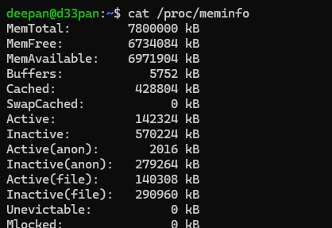

23. cat/proc/version Interpretation:

displays the system information in quick summary

Output:



1. hdparm -i /dev/sda Interpretation:

provides a command line interface to various kernel interfaces supported by the Linux SATA/PATA/SAS "libata" subsystem and the older IDE driver subsystem

Output:

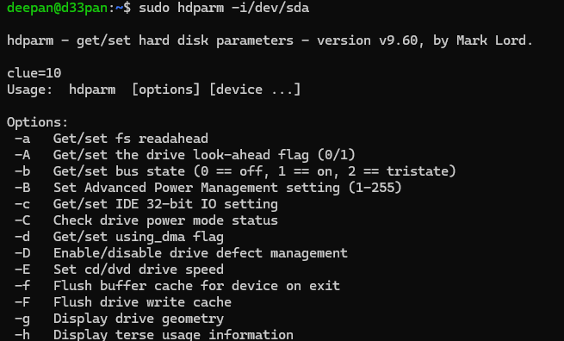

1. uname

Interpretation:

prints the system information Output:





1. uname -v Interpretation:

print the kernel version

Output:



1. uname -r Interpretation:

print the kernel release

Output:



1. uname -m

Interpretation:

print the machine hardware name



1. uname -a Interpretation:

print all informations like kernel name,network node hostname, kernel release and version,machine hardware name, processor type,etc.

Output: 

1. sudo lshw -html>lshw.html Interpretation:

lshw command is used to generate the detailed information of the system's hardware configuration from various files in the /proc directory and is saved in lshw.html

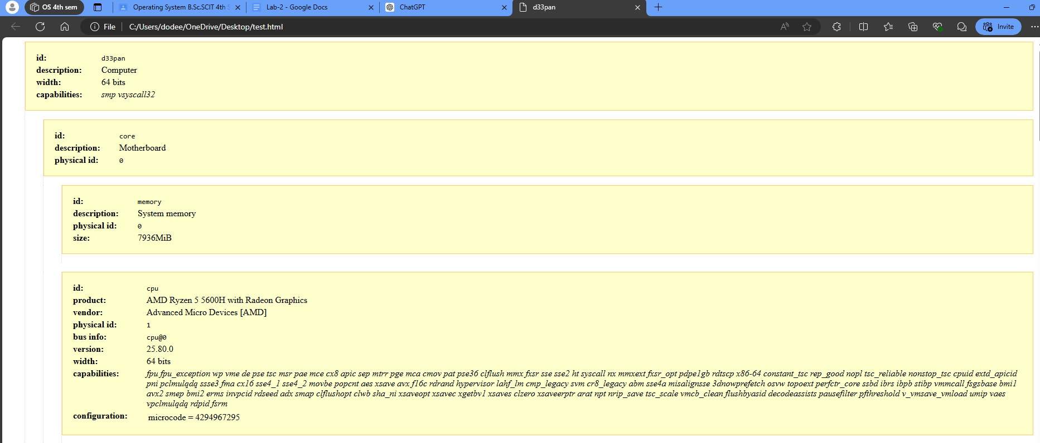Output:

32. factor 1203343 Interpretation:

print the prime factors of the given numbers, either given from command line or read from standard input

Output:

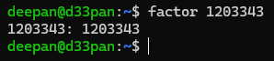

33. echo **‘**3*9**’**| bc Interpretation:

echo displays the string passed and ‘|’ symbol is used to redirect the output of echo to arbitrary precision calculator language bc to produce the product of

3 and 9 Output:



34. echo **‘**(6*5)-8**’**| bc Interpretation:

calculates the give expression and displays in the terminal Output:



1. id

Interpretation:

print real and effective user and group IDs Output:



1. lsusb | tee lsusb.txt Interpretation:

lsusb outputs all the usb devices and ‘|’ symbol redirects the output of lsusb into file lsusb.txt

Output:



1. cat lsusb.txt Interpretation:

reads the file lsusb.txt Output:



1. shutdown Interpretation:

schedule the shutdown of the system after one minute Output:



1. shutdown now Interpretation:

power-off the machine instantly Output:



1. shutdown 13:20 Interpretation:

This command shuts down the machine at 13:20 Output:



1. shutdown 10 Interpretation:

schedule the shutdown of the system after ten minutes Output:



1. shutdown -r +10 Interpretation:

schedule the shutdown of the system after ten minutes Output:



1. shutdown -c Interpretation:

Cancel a pending or scheduled shutdown.

Output:



1. ping -w 3 google.com Interpretation:

send ICMP ECHO_REQUEST to google.com Output:

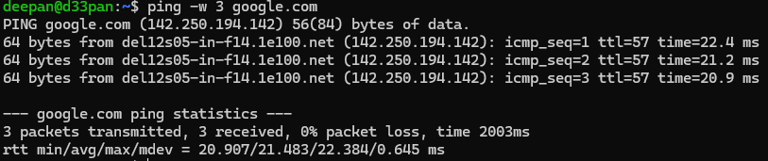

1. netstat

Interpretation:

Print network connections, routing tables, interface statistics, masquerade connections, and multicast memberships

Output:

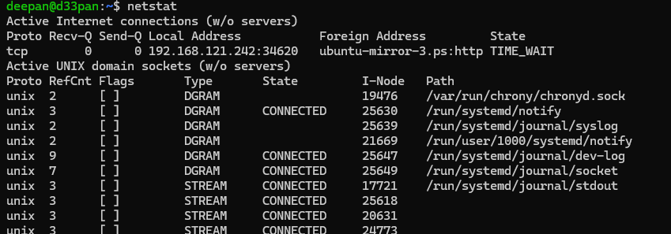

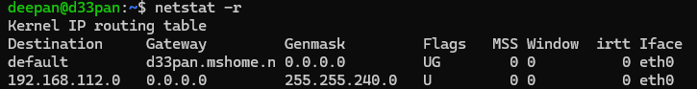

47. netstat -p Interpretation:

Show the PID and name of the program to which each socket belongs. A hyphen is shown if the socket belongs to the kernel (e.g. a kernel service, or the process has exited but the socket hasn't finished closing yet).

Output:



1. host google.com Interpretation:

performs DNS lookups. It is normally used to convert names to IP addresses and vice versa.

Output:

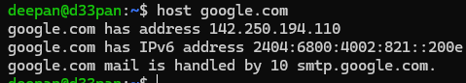

1. tracepath achsnepal.edu.np Interpretation:

traces path to a network host discovering MTU along this path Output:

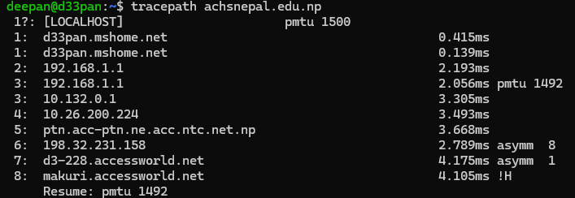

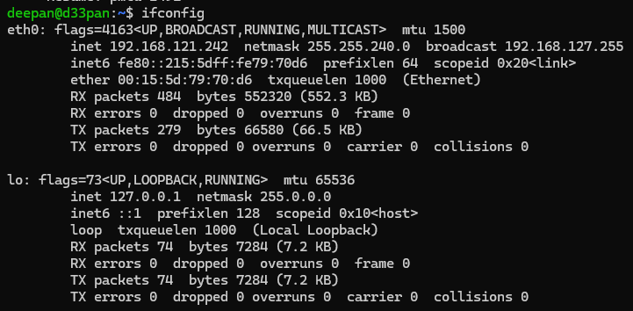

52. route

Interpretation:

show / manipulate the IP routing table Output: 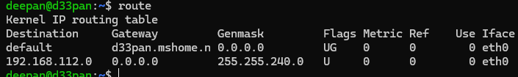

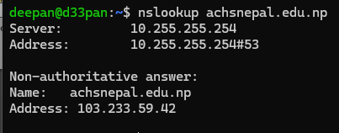

54. whois brainyquote.com Interpretation:

guess the right server to ask for the specified object. If no guess can be made it will connect to whois.networksolutions.com for NIC handles or whois.arin.net for IPv4 addresses and network names.

Output:

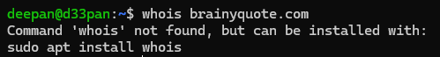

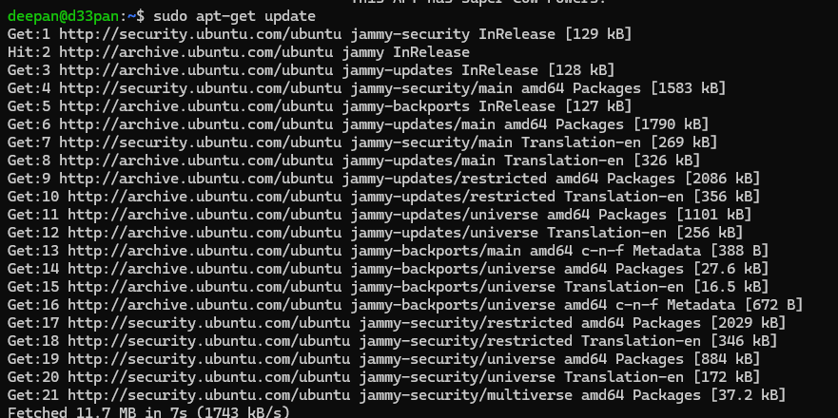

1. sudo apt-get upgrade Interpretation:

install the newest versions of all packages currently installed on the system from the sources enumerated in /etc/apt/sources.list

Output:

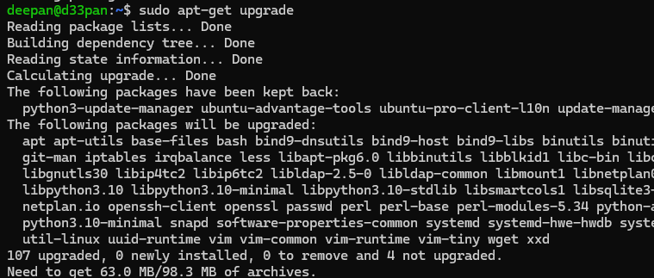

1. sudo apt-get install sl Interpretation:

install package sl Output:

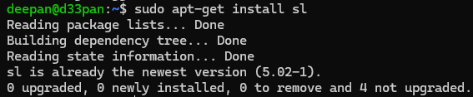

ls Output:

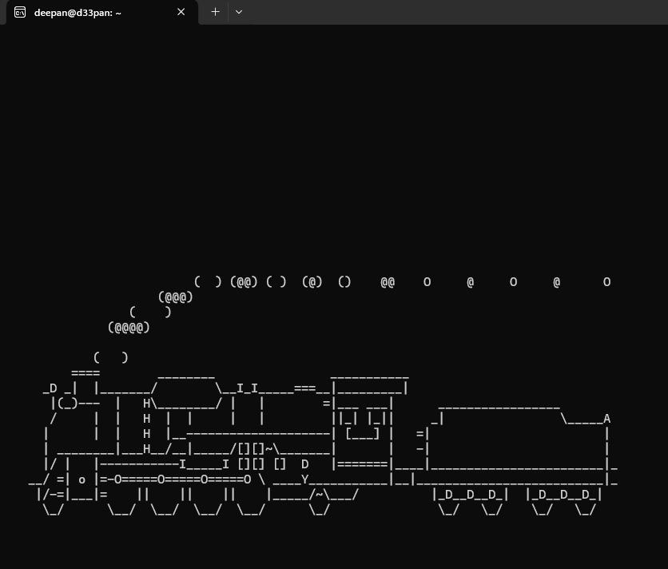

1. sudo -s

Interpretation:

Run the shell specified by the SHELL environment variable if it is set or the shell specified by the invoking user's password database entry.

Output:

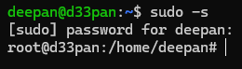

1. exit

Interpretation:

exit the current program

Output:

